**ICC**

**K20-1052**

**HASSAN ALI**

**Task:**

**Create a Windows VM and assign public subnet of the VPC created. Then create a Linux VM that should be assigned private subnet of VPC. Access the Linux VM in the Windows VM using SSH.**

**Create a Windows VM**

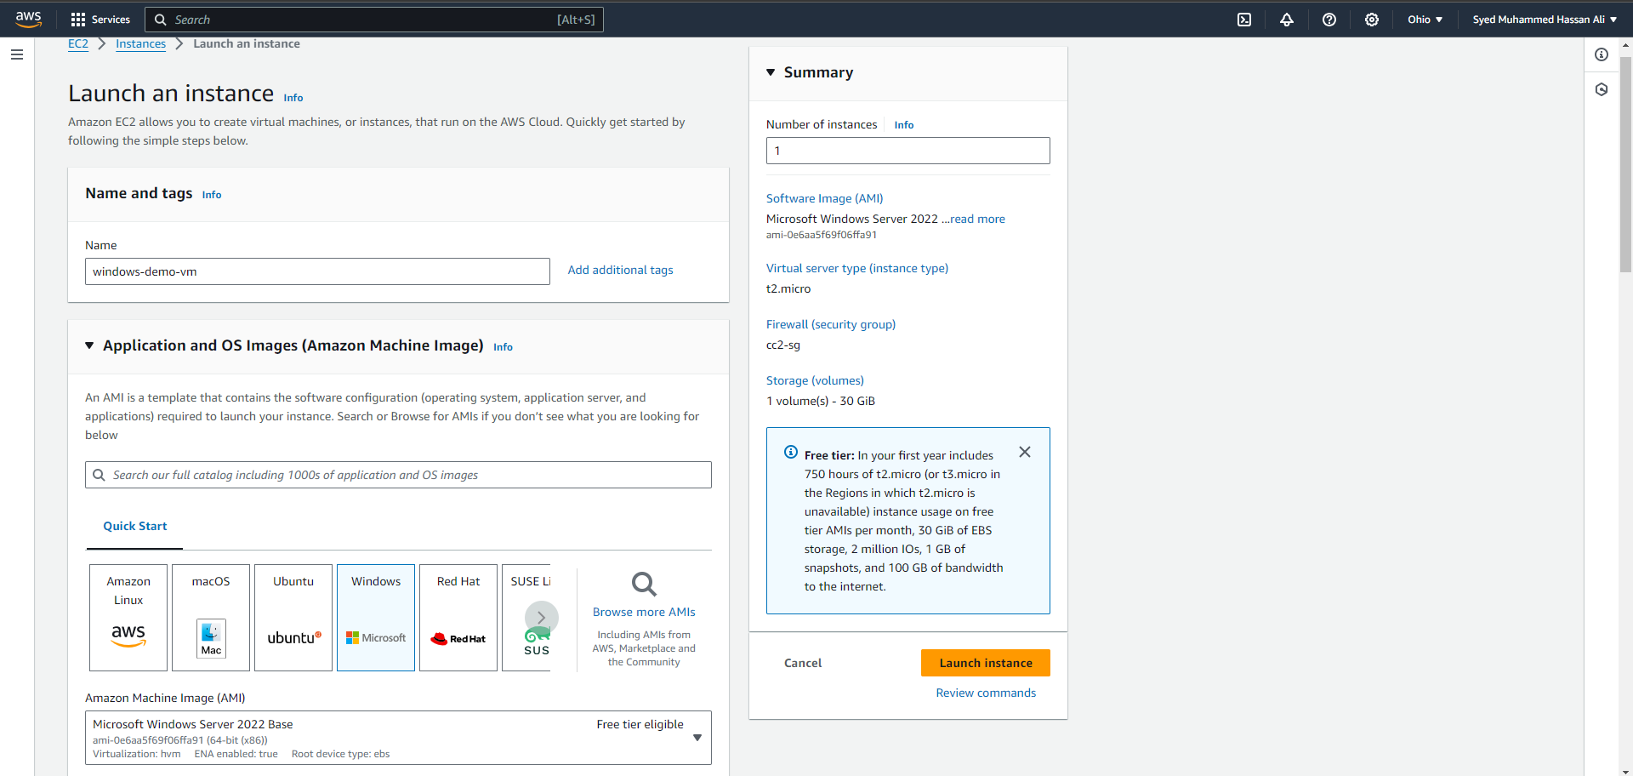

**Generate Key pair, choose your previously created VPC with a public subnet. Also choose the existing security group**

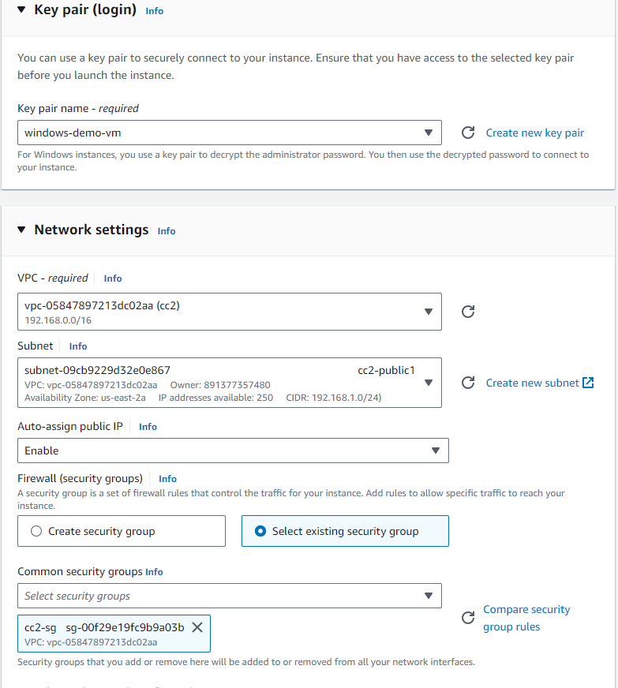

**Windows VM is up and running**



**Now download RDP client to use your vm**

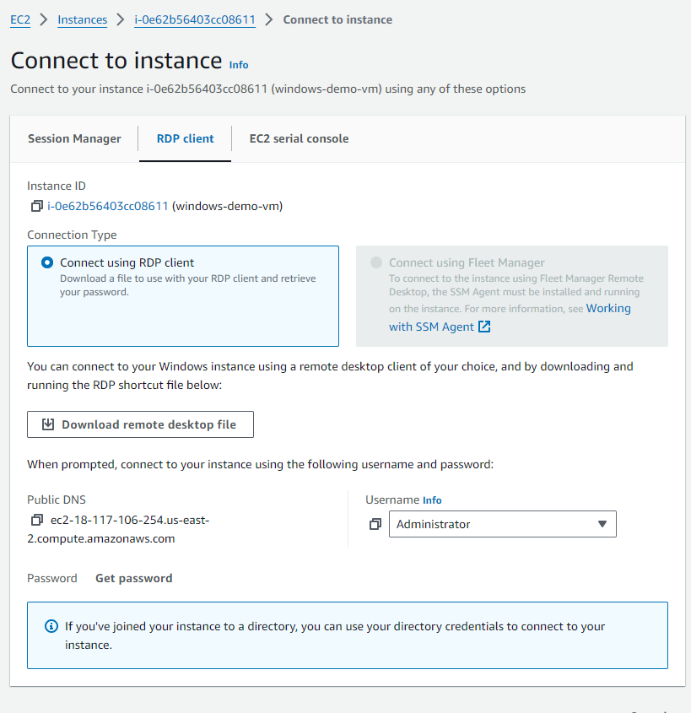

**Decypt the private key to get the password of the VM**

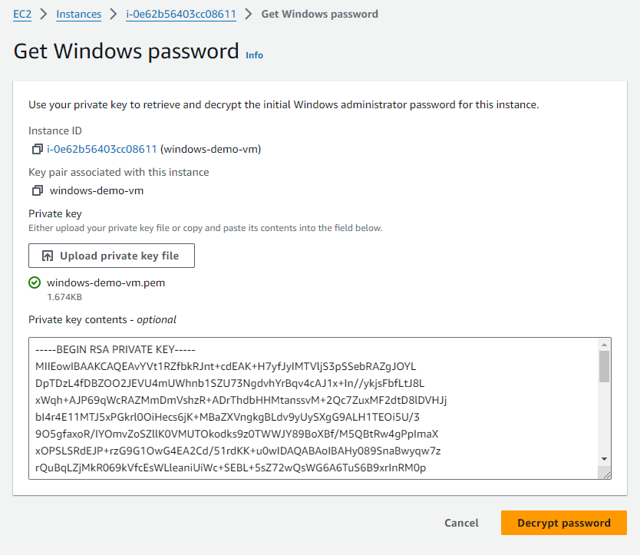

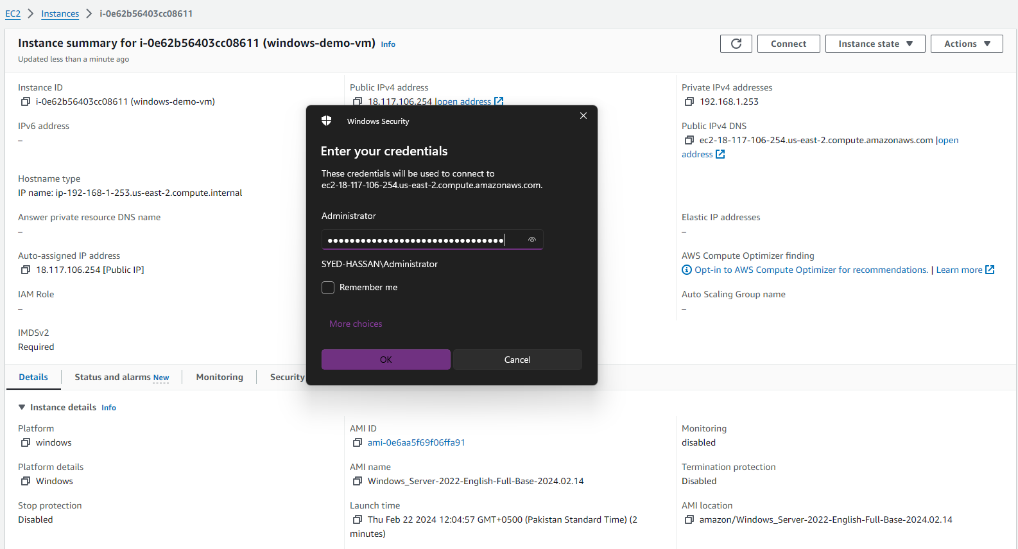

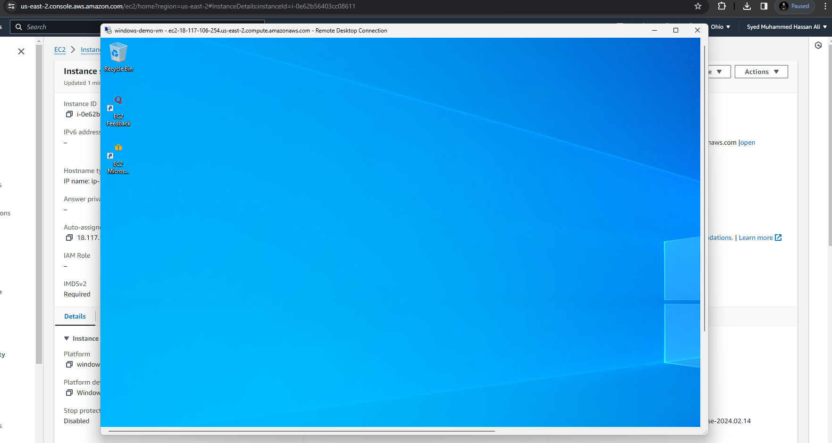

**Now Open Aws console in windows VM and Create another linux machine**

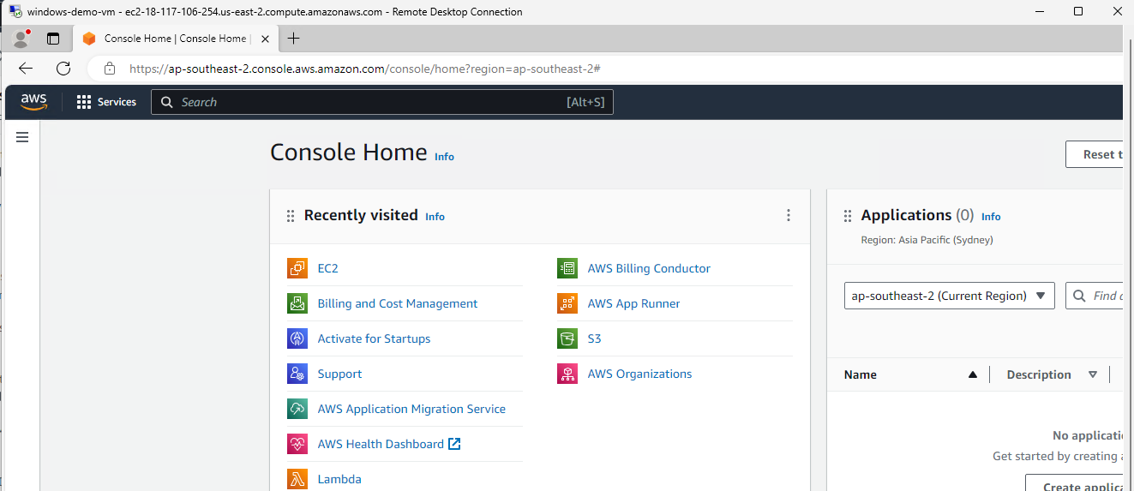

**Choose private subnet of the VPC where IG is not accessible (by default dynamic IP is disabled)**

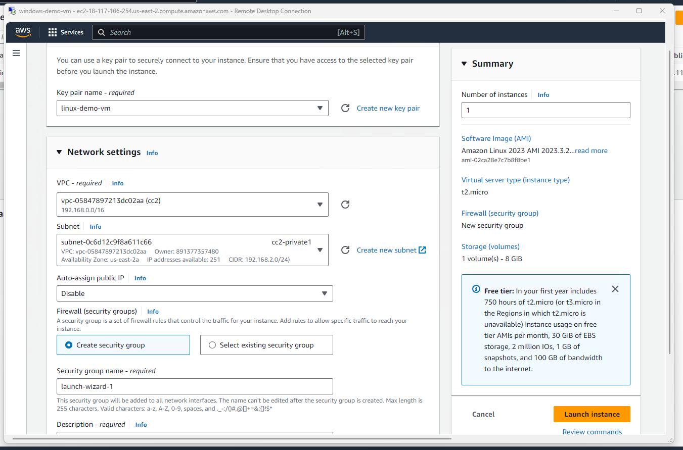

**Both of the VMs are up and running**

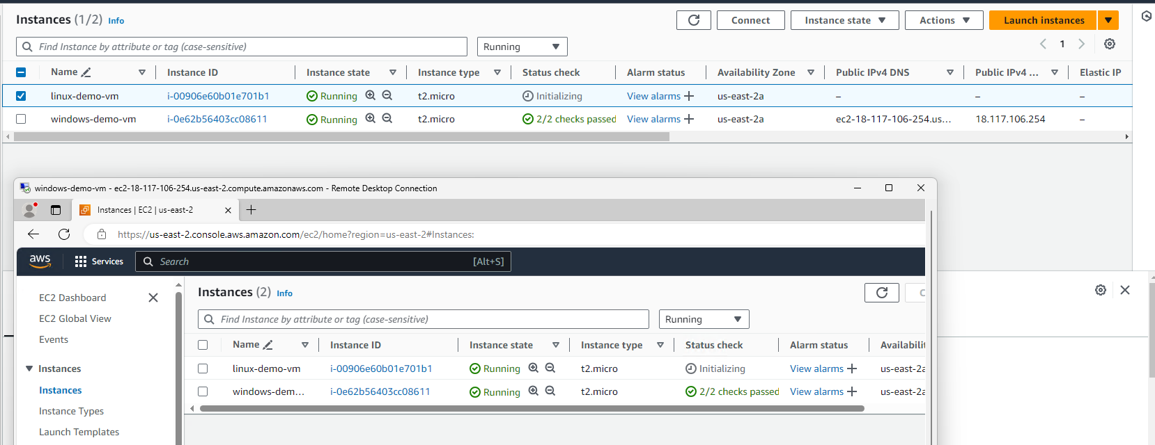

**Now connect your linux VM using SSH client. Copy paste the SSH command to the terminal**

